C# Web Basics Exam – 16 June 2019

SULS
Exam problems for the C# Web Basics course @ SoftUni. Submit your solutions in the SoftUni judge system (delete all "bin"/"obj" folders).
SULS is an online judge platform which manages problems and submissions of users. You have been tasked to implement a platform in which the users can create problems or submit solutions to other users' problems.

Technological Requirements
- Use the SIS.WebServer
- Use the SIS.MvcFramework
- Use Entity Framework Core
The Technological Requirements are ABSOLUTE. If you do not follow them, you will NOT be scored for other Requirements.
Now that you know the Technological Requirements, let us see what the Functional Requirements are.

Database Requirements
The Database of SULS needs to support 3 entities:

User
- Has an Id – a string, Primary Key
- Has a Username – a string with min length 5 and max length 20 (required)
- Has an Email - a string, which holds only valid email (required)
- Has a Password – a string with min length 6 and max length 20 - hashed in the database (required)

Problem
- Has an Id – a string, Primary Key
- Has a Name – a string with min length 5 and max length 20 (required)
- Has Points– an integer between 50 and 300 (required)

Submission
- Has an Id – a string, Primary Key
- Has Code – a string with min length 30 and max length 800 (required)
- Has Achieved Result – an integer between 0 and 300 (required)
- Has a Created On – a DateTime object (required)
- Has Problem – a Problem object
- Has User – a User object
Implement the entities with the correct datatypes and their relations.

Page Requirements

Index Page (logged-out user)
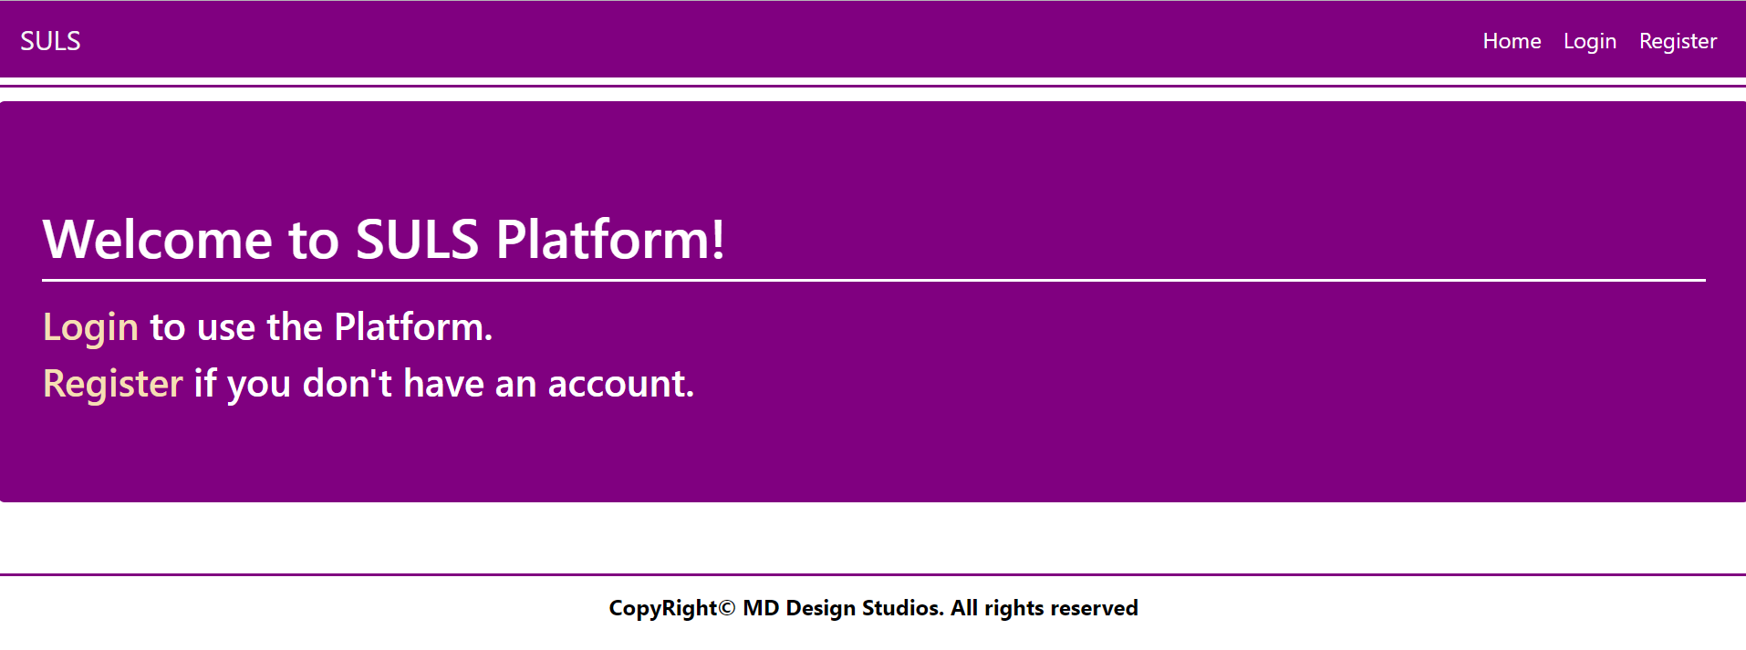

Login Page (logged-out user)
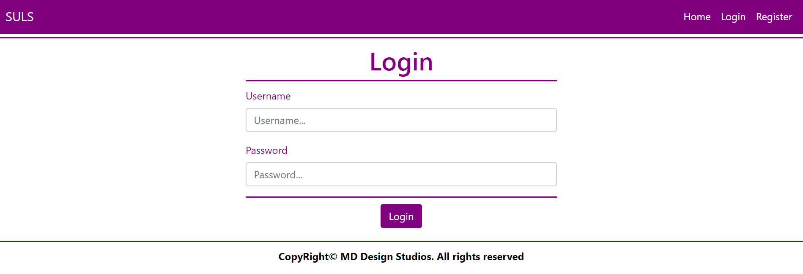

Register Page (logged-out user)
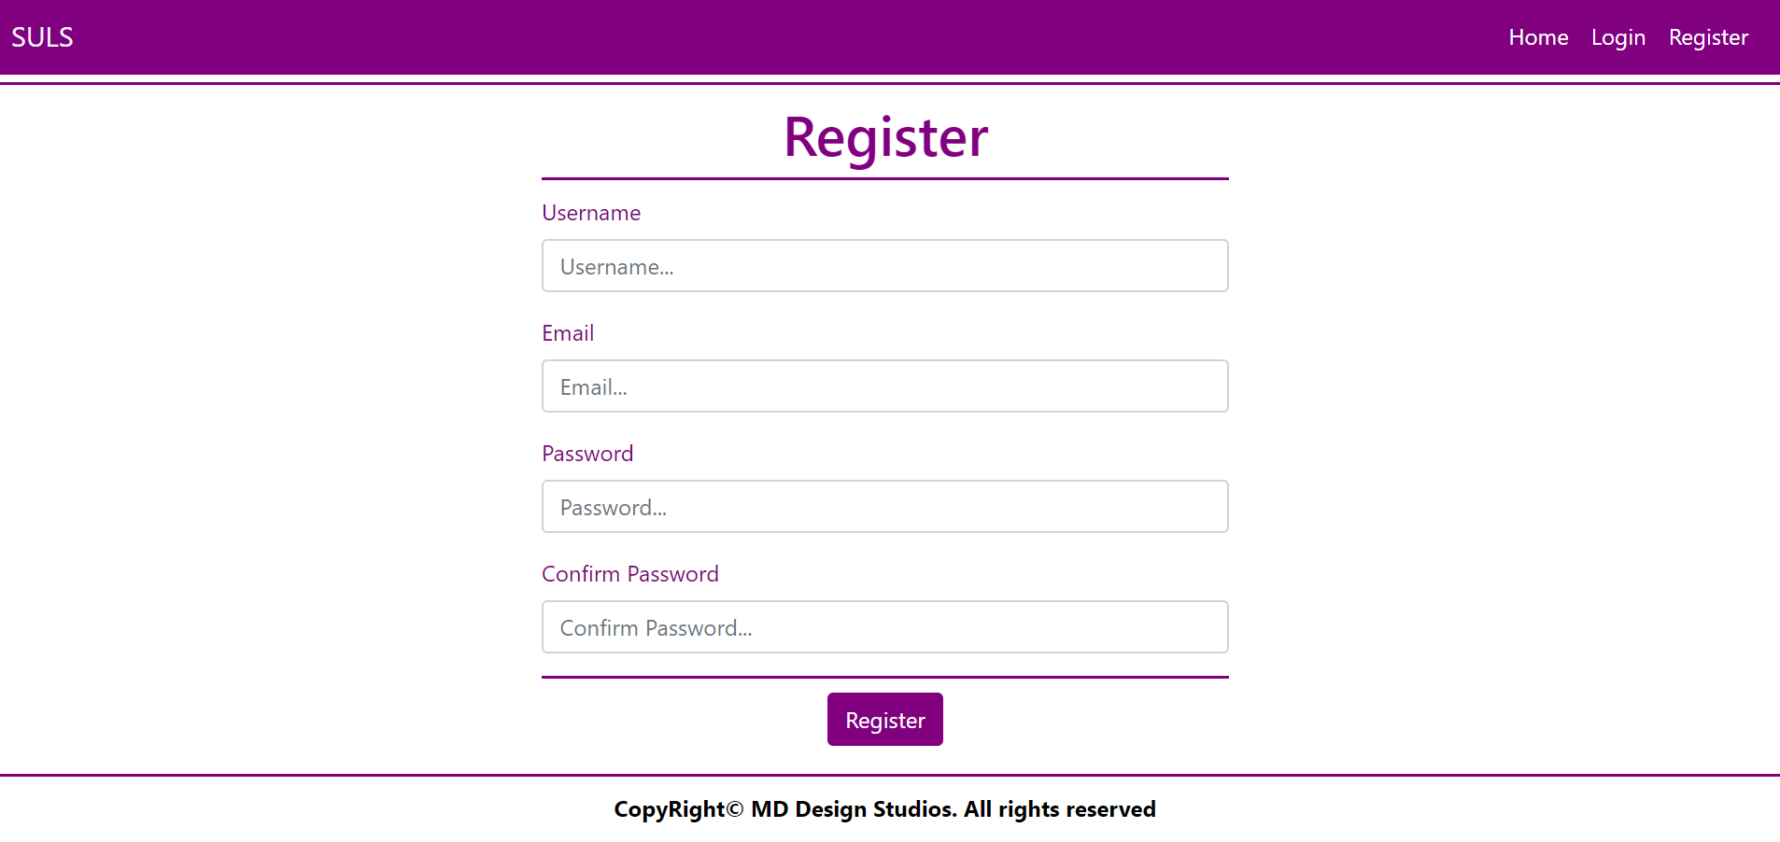

Home Page (logged-in user)
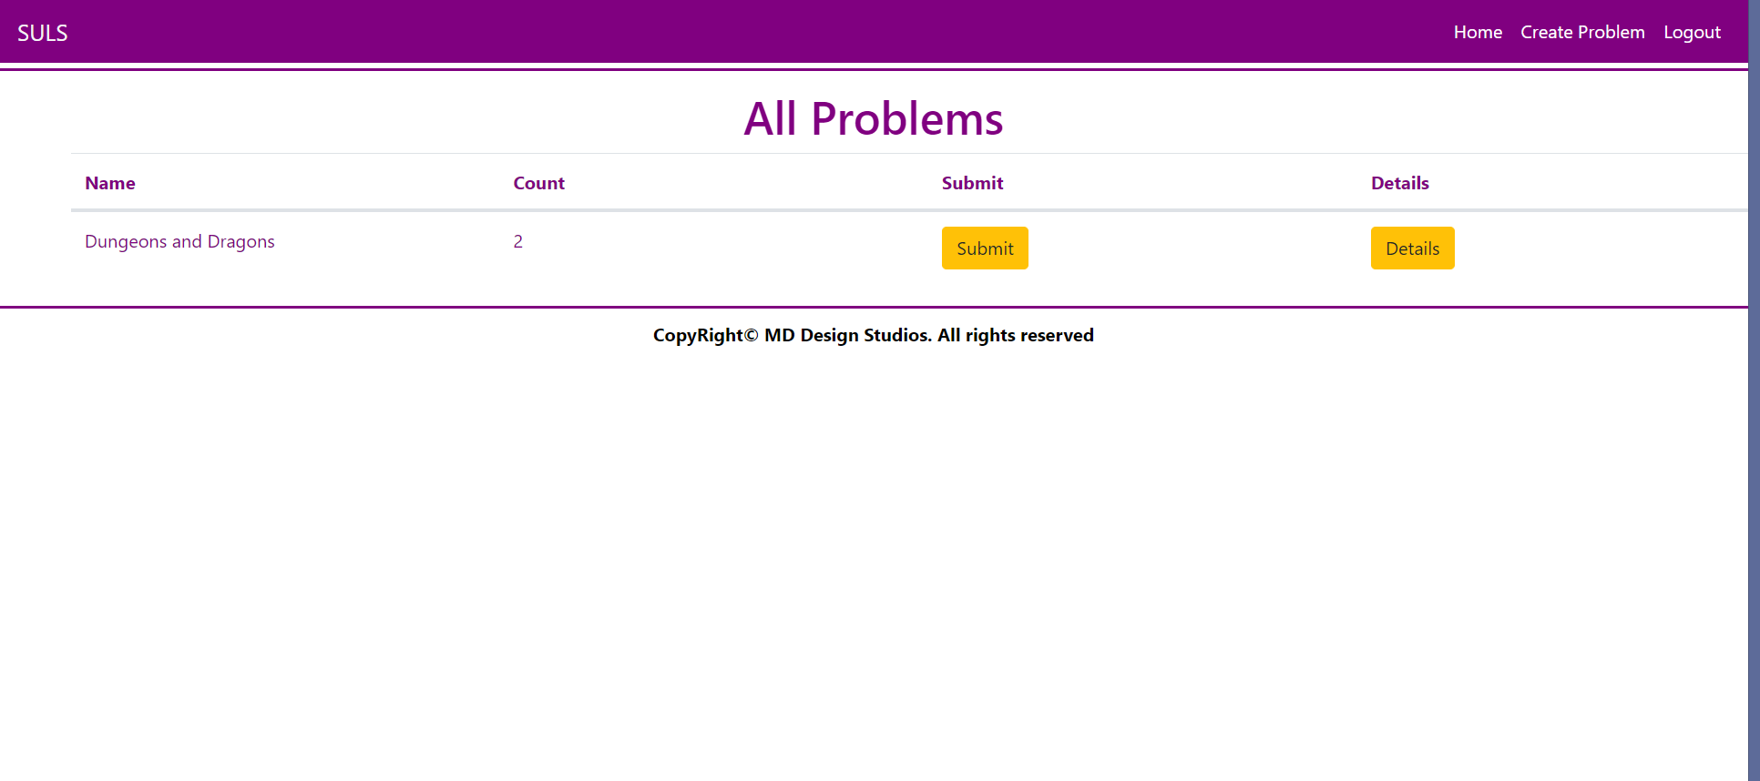
NOTE: The [Submit] and [Details] buttons lead to the Create Submission Page and Details Problem Page respectively.

Problem Create Page (logged-in user)
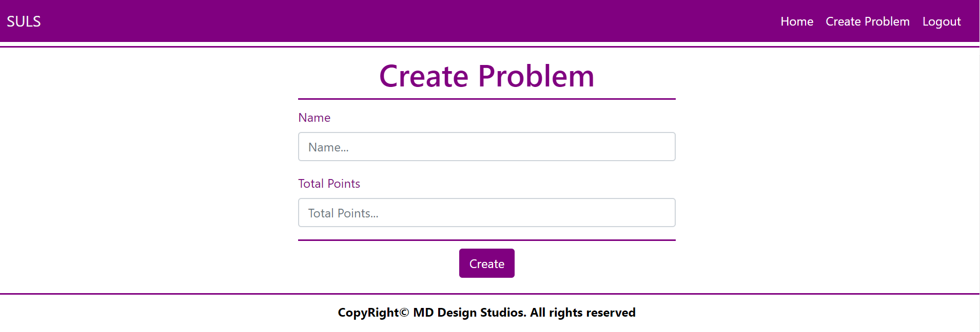

Problem Details Page (logged-in user)
DATE format!!!
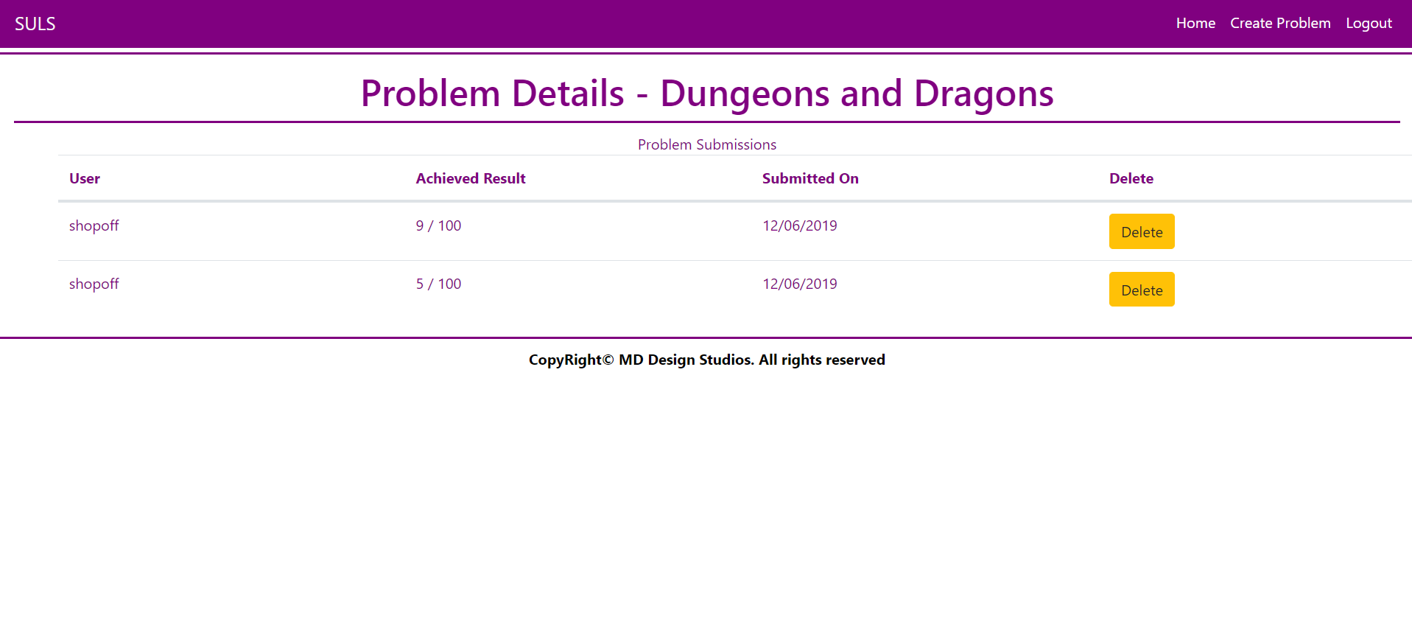
NOTE: All Submissions for the current Problem are rendered below in the Problem Submissions section.
NOTE: Submissions are visualized with percentage Achieved Result / Problem Total Points, rounded to the closest integer.

Create Submission Page (logged-in user)
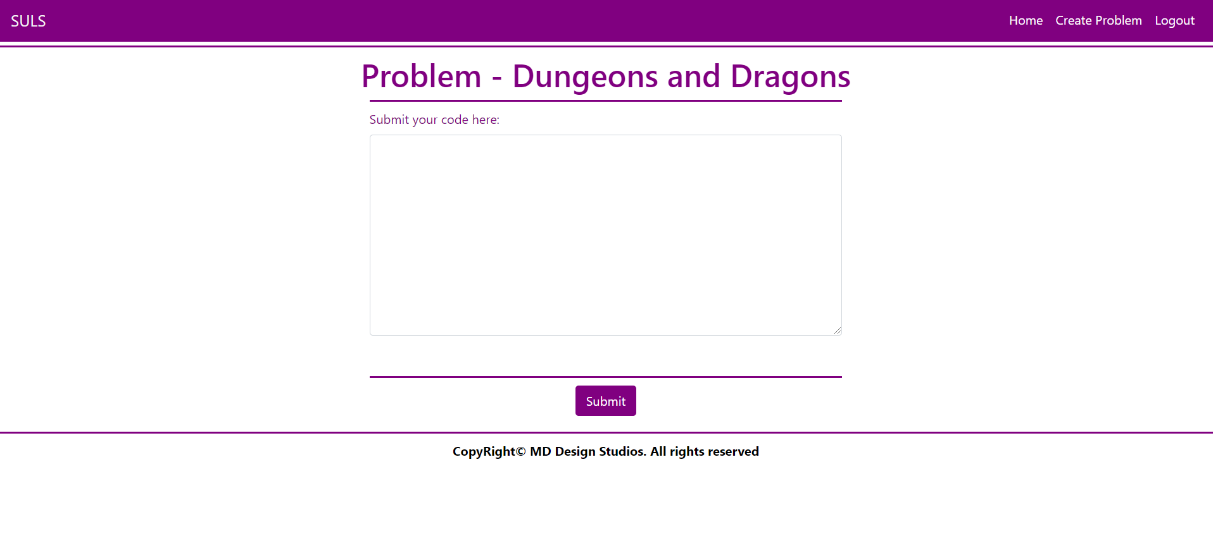
NOTE: The Submission Code will be sent from a <textarea>, as a whole string.
NOTE: The templates should look EXACTLY as shown above.
NOTE: The templates do NOT require additional CSS for you to write. Only bootstrap and the given css are enough.

Functionality
The functionality of SULS Platform is very simple.

Users
Guests can Register, Login and view the Index Page.
Users can Create Problems and see Created Problems on the Home Page. From the Home Page they can also view Details about each one of those Problems or Submit a Submission to that Problem. Users can also delete submissions from the table with the Problem Submissions on the Problem Details Page.

Problems
Problems can be Created by Users. All created Problems are visualized on the Home Page, each one in its own separate rectangular element.
Problems are visualized on the Home Page as a table with Name of the Problem, Count of Submissions and actions like Submit and Problem Details.
Problems are visualized on the Home Page with 2 buttons – [Submit] and [Details].
- The [Submit] button leads to the Create Submission Page
- The [Details] button leads to the Details Page

Submissions
Submissions can be created by Users for a Problem. All created Submissions, for a Problem, are visualized on that Problem’s Details Page.
Submissions’ Code is created from a <textarea>, which submits a giant text string.
- Upon creation, the Submission’s Achieved Result property should be set to a random value
between 0 and the Problem’s Total Points.
- Upon creation, the Submission’s Created On property should be set to the current Date and Time.
- Upon creation, the Submission’s User property should be set to the currently logged-in user.

Redirections
- Upon successful Registration of a User, you should be redirected to the Login Page.
- Upon successful Login of a User, you should be redirected to the Home Page.
- Upon successful Creation of a Problem, you should be redirected to the Home Page.
- Upon successful Creation of a Submission, you should be redirected to the Home Page.
- Upon successful Deletion of a Submission, you should be redirected to the Home Page.
- Upon successful Logout of a User, you should be redirected to the Index Page.

Security
The Security section mainly describes access requirements. Configurations about which users can access specific functionalities and pages:
- Guest (not logged in) users can access Index page.
- Guest (not logged in) users can access Login page.
- Guest (not logged in) users can access Register page.
- Users (logged in) cannot access Guest pages.
- Users (logged in) can access Home page.
- Users (logged in) can access Problem Create page and functionality.
- Users (logged in) can access Problem Details page.
- Users (logged in) can access Submission Create page and functionality.
- Users (logged in) can delete Submissions.
- Users (logged in) can access Logout functionality.

Code Quality
Make sure you provide the best architecture possible. Structure your code into different classes, follow the principles of high-quality code (SOLID). You will be scored for the Code Quality and Architecture of your project.

Data Validation
- In case of invalid data during the login, redirect to "/Users/Login"
- In case of invalid data during the registration, redirect to "/Users/Register"
- In case of invalid data during the submissions creation, redirect to "/Submissions/Create"
- In case of invalid data during the problems creation, redirect to "/Problems/Create"
NOTE: Use the ValidationSisAttributes

Scoring

Database Requirements – 10 points.

Template Requirements – 10 points.

Functionality – 40 points.

Security – 10 points.

Application Structure – 10 points.

Data Validation – 20 points.

